ls-to list all files

mkdir-to make folder

cd- to move ahead

cd .. -to move back

cd ~ -to move to root

Arrow up – to check prv command

Tab-to auto complete

Ctrl+u – to delete the entire line

Ctrl+a -to move to start of the command

Ctrl+e – to move to end ……………………….

start t.txt- opens t.txt file

rm t.txt – deletes t.txt

clear – to clear terminal

…………………………………………………………………………………………………………………………………………………………………

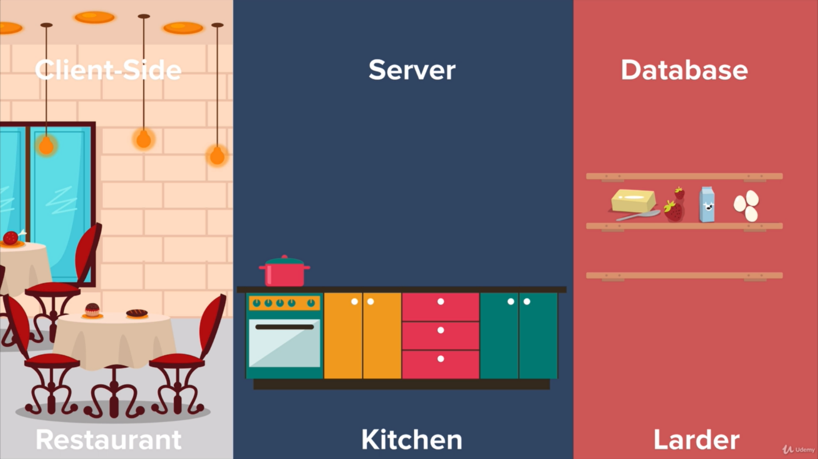

To use npm –

1)npm init

2)write all details

3)install npm package from npm.com and use(documentation)

**Express.js**

1)node init

2)node install express(to install express package in your folder)

3)

Req=request,res=respond ,app.listen the url request of website, app.get sends the data from express srever to website.

const express=require('express');

const app=express();

app.get("/",function(req,res)

{

    res.send("<h1>Hello Bacho</h1>");

    console.log(req);

})

app.listen(3000,function()

{

    console.log("Server started on port 3000");

})

4)To send html file use-

app.get("/",function(req,res)

{

    res.sendFile(__dirname+"/index.html");

})

//__dirname=curr file path relative to root

5)To receive post request use-

npm install body-parser,use app.post,require(“body-parser”),app.use(……….)

const express=require("express");

const app=express();

const bodyParser=require("body-parser");

app.get("/",function(req,res)

{

    res.sendFile(__dirname+"/index.html");

})

//__dirname=curr file path relative to root

app.use(bodyParser.urlencoded({extended:true}))

app.post("/",function(req,res)

{

    // console.log(req.body);

    var n1=Number(req.body.num1), n2=Number(req.body.num2);

    var result=n1+n2;

    res.send("Addition is "+result);

})

app.listen(6969,function()

{

    console.log("Server started on prt 6969");

})